Interactive map U5 building - 1st floor
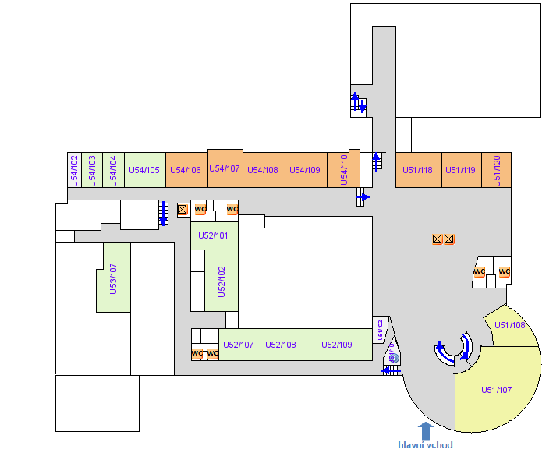

Interactive map U5 building – 2nd floor

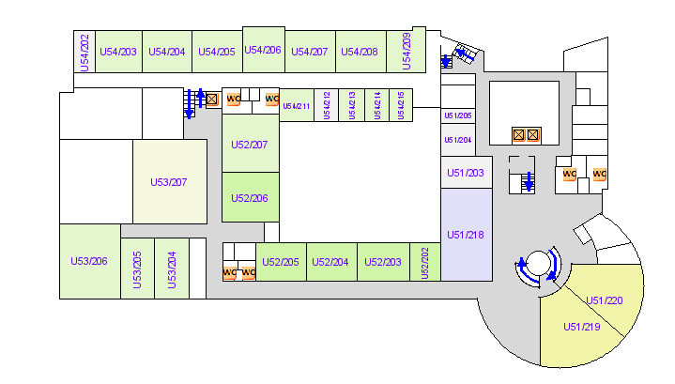Interactive map U5 building – 3rd floor

